Brand Guidelines
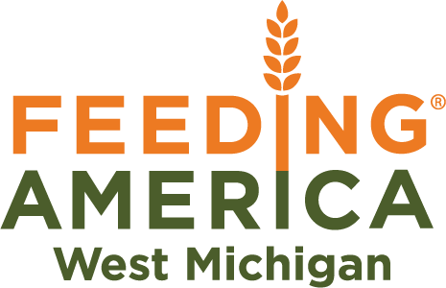

Table of Contents

Introduction  Brand Positioning  - Name  - The fundamentals  - Goals  Brand Personality  - Rhetorical appeals  Brand Imagery and Design  - Images by type  - Logo  - Wheat Stalk  - Color palette  - Design | Brand Language  - How to talk about ____  - Calls to Action  Facts and Figures  Typography and Writing Style  - Voice  - Fonts  - Font styles  - Email  - Letters, cards and postcards  - Punctuation and mechanics

Introduction

Feeding America West Michigan depends on the support of the community to fulfill our mission. We can only gain that support if the community understands who we are and what our mission is.

This guide provides resources for speaking, writing and designing visual content on behalf of the food bank so that all staff and board members can communicate our mission clearly and consistently.

This document also defines the appropriate treatment of Feeding America West Michigan's brand elements, such as our logo, color palette, typography, imagery style and language.

These brand guidelines were developed with a lens for marketing materials and general public-facing communication.

Brand Positioning

Name:

The preferred term for our organization is Feeding America West Michigan. It is also acceptable to refer to our organization as “the food bank” when the context is clear. Please note: “food bank” should not be capitalized as it is no longer part of our name, therefore it is not a proper noun. As a comparison, “Kent District Library” would be capitalized, whereas “the library” wouldn’t be. Never refer to our organization as “Feeding America.” It creates confusion for external audiences who may not understand our relationship with the Feeding America National Organization. Do not use the acronyms “FAWM” or “FA” in any external communication.

Belief: Our core conviction

We believe hunger is unacceptable and that our community has the power to change lives – one meal at a time.

Vision: The future state we work to achieve

We envision a community in which all neighbors are nourished and empowered within an equitable food system.

Mission: Why we exist

We gather and distribute food to relieve hunger and increase food security in West Michigan and the Upper Peninsula.

Values: How we act

Respect, transparency, excellence, inclusion, innovation, stewardship, integrity and collaboration.

Overarching goals of marketing & communication work:

To foster empathy for those facing hunger and mobilize our community to take action against hunger.
Brand Personality

Brand personality informs the way we would like to be seen by our community and how we communicate with them. Use it as a guide when considering if/how Feeding America West Michigan would say or do something and the kind of individuals with whom the brand would align.

We are the everyday hero. We are empathetic to the people we serve, acting as a powerful voice that promotes positivity and embraces respect. We are deeply committed to our mission because we know food is what allows people to thrive. We are resourceful and collaborative, relying on our partnerships to help make the most impact in the lives of the people we serve. We’re the authority on hunger, but we speak in a friendly and relatable manner.

Utilize rhetorical appeals that reflect this personality when communicating (in any form) as a representative of our brand. These three modes of persuasion will help foster empathy for people facing hunger in order to achieve our goal of mobilizing our community to take action against hunger.

Pathos – pull on heartstrings (emotion)
Logos – provide logical arguments (use facts/data)
Ethos – show credibility (ethics)

Brand Imagery and Design

Imagery plays a powerful role in expressing our brand.

We want to capture images that stand out in a cluttered environment and inspire empathy.

When choosing photographs, use candid, realistic pictures instead of over-stylized or posed photos.

Always apply a lens of equity, diversity and inclusion when selecting imagery.

Photos and icons can be found in the shared drive.
Use the following click path (filesrvr > FAWM Shared Documents >Marketing & Communication > Photos).

Photos and icons can also be found on HungerNet.

HungerNet’s media library can be accessed by hovering over “functional areas,” clicking on “marketing and communication,” and then choosing “media library” on the left hand side of the screen.

After three years, whether sourced from HungerNet or our internal photo library, client photos are archived and may not be used again for any purpose. Some photos may have been taken a year or two ago and have a shorter usage window — so be sure to check the expiration date, or ask the communication team if you are unsure.

Stock photos that fit our brand style can also be used.

Free stock photos can be found at unsplash.com and pixabay.com.

If you have questions about our brand style, please ask a member of the communication team.

Third-party photos can be used if appropriate credit is given (photo courtesy of ___).

No other sources may be used unless approved by the communication team.
Logo

More than just a logo — our brand is a symbol for hope and the end of hunger.

There are three variations of the logo: the primary full-color option, 1-color white and 1-color black. The full-color version is the primary version and its use is preferred. The 1-color versions may be used when the full-color logo is not visible on a certain background color. To ensure the logo’s visibility, a generous area of clear space should always surround it.
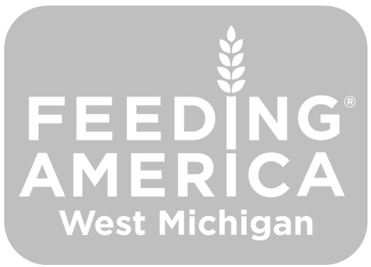
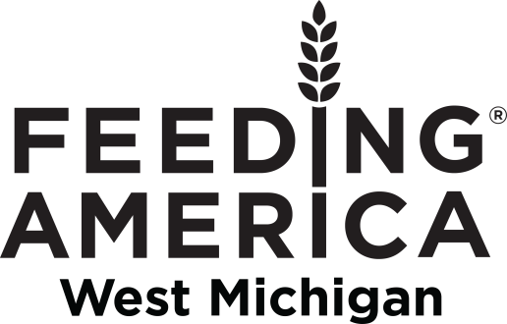

The full logo or wheat stalk (explained in the next section) must be used in all external communication including but not limited to emails, letters, postcards, newsletters, flyers, brochures, t-shirts, buttons, stickers, etc. In 2021, the full-color logo changed slightly. Don’t use the 2015 version of the full-color logo. The 1-color white and black can still be used.

When using the full-color logo (which is preferred), it is recommended to appear on a light background for optimal visibility. It should never be used on a dark colored background. This ensures it's always readable and ADA-compliant. The 1-color logos can appear on both black and colored backgrounds. When using a color background always ensure that there is sufficient contrast between the logo and the background.

The shape of the logo should never be altered. While you can adjust the size of the logo, never skew it or add effects. It should never appear smaller than 1” when printed or 98 px in digital applications. If it appears pixilated, it’s too big. There are other restrictions outlined on pages 12-19 of Feeding America’s 2021 brand guidelines. While not exhaustive, they showcase some common mistakes that don’t align with the National Organization’s brand guidelines and therefore, ours.

You can find the food bank’s logos in the FAWM Shared Documents folder on the server (filesrvr > FAWM Shared Documents > Logo).
Wheat Stalk

The Feeding America wheat stalk symbolizes hunger relief. It is one of the national organizations key visual assets to generate awareness for the issue of hunger, and also represents the Feeding America network of food banks (like Feeding America West Michigan). The symbol is composed of a vertical stalk on the bottom and nine kernels above. There should always be exactly nine kernels in the wheat stalk.

Its orange color signifies hunger and the Feeding America brand. The wheat stalk is a registered trademark so any time an approved iteration of the wheat stalk symbol is used, an ® symbol must be included.

Note that the wheat stalk symbol has a shorter stalk than the wheat stalk in the Feeding America logo, which creates a more iconic and easier-to implement mark.

In some instances, it is okay to use the wheat stalk symbol without the stalk, but ® rules still apply.

The orange full-color version is preferred, but black and white versions are also available.

To ensure the symbol’s visibility, a generous area of clear space should always surround it. This protects the symbol from competing visuals such as text and graphics and builds long-term recognition for our campaign.

When the symbol is reproduced at small sizes, it should appear no smaller than 0.5” or 30 px tall for all applications. This ensures that our symbol is always clear and legible.

The symbol must be used correctly in order to maintain brand integrity and consistency.
Note that any alteration of the symbol is considered misuse. Only use supplied digital
artwork. Any questions regarding the use of the wheat stalk should be directed to the
Feeding America marketing team.

You can find the wheat stalk files in the FAWM Shared Documents
folder on the server (filesrvr > FAWM Shared Documents > Logo).

Color Palette

Our full color palette (updated in 2021) provides a range of dynamic options that work with our primary brand colors. Use them as accents in type and backgrounds, but always make sure our brand colors shine.

Primary Brand Colors

These are our hero colors. Green represents growth, vitality, and renewal. Orange is the color of the hunger movement and conveys energy and optimism. White is an important part as well, as it ensures all of our colors have sufficient contrast and remain ADA compliant.

White

CMYK 0/0/0/0
RGB 255/255/255
Hex FFFFFF
Brand Orange
PMS 138

CMYK 0/54/100/1
RGB 222/124/0
Hex DE7C00
Brand Green
PMS 574

CMYK 49/22/85/58
RGB 78/91/49
Hex 4E5B31

Secondary Colors

These should support and complement the primary brand colors.
Light Blue
PMS 7457

CMYK 25/0/0/0
RGB 187/221/230
Hex BBDDE6
Pale Yellow
PMS 127

CMYK 0/3/63/0
RGB 243/221/109
Hex F3DD6D
Warm Yellow
PMS 123

CMYK 0/25/94/0
RGB 255/184/28
Hex FFB81C

Pale Teal
PMS 5523

CMYK 27/5/8/0
RGB 182/207/208
Hex B6CFD0
Deep Green
PMS 560

CMYK 86/30/65/75
RGB 29/60/52
Hex 1D3C34
Medium Blue
PMS 302

CMYK 100/32/0/68
RGB 0/59/92
Hex 003B5C

Tertiary Colors
These should only be used in limited situations as accents.
Cool Grey
Cool Grey 1C

CMYK 10/7/5/0
RGB 217/217/217
Hex D9D9D9
Brown
PMS 476

CMYK 33/66/76/68
RGB 78/54/41
Hex 4E3629
Sand
PMS 719

CMYK 1/18/31/0
RGB 237/200/163
Hex EDC8A3
Maroon
PMS 1805

CMYK 0/75/67/30
RGB 178/45/58
Hex B22D3A
Payne’s Grey
PMS 432

CMYK 78/57/39/56
RGB 51/63/72
Hex 333F48

Note: Only use maroon for calls-to-action

Color Emphasis

Each color should be emphasized differently and the colors should not all be used at the same time.

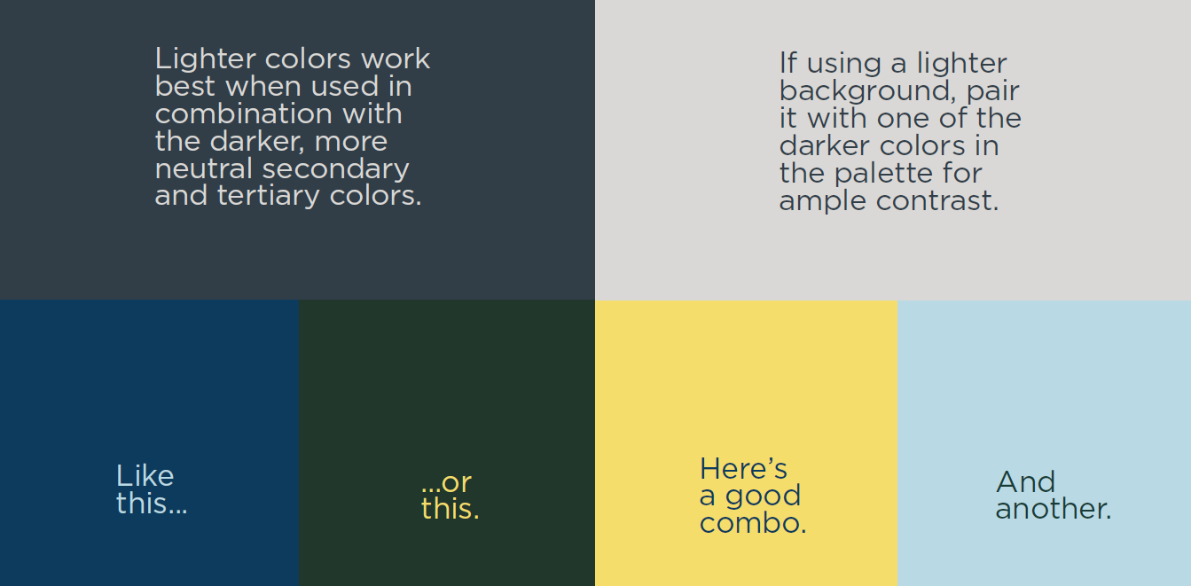

Ensure proper contrast is achieved at all times. Brand Orange, in particular, presents certain issues when used, especially in digital applications, as it lacks sufficient contrast to be ADA compliant at certain sizes. With this color, large copy is fine but body copy is not.

Design

#1 Rule: Content informs design!

Elements of Design
- Typeface & fonts  - White space  - Layout  - Boxes  - Lines | - Illustrations  - Icons  - Lists (numbers and bullets)  - Arrows

4 Basic Design Principles

Keep the 4 basic design principles (ironic acronym CRAP) in mind no matter what you are designing.

The following information came from chapter 5 of A Strategic Guide to Technical Communication, written by Heather & Roger Graves.
- Contrast – The primary rule of contrast is that you either make two items identical or make them look obviously different. Contrast creates visual interest on the page.
Note: font, text size and color, bolding and underlining can all create contrast, but remember that less is more. You shouldn’t use more than two of these elements at the same time.
- Repetition – Incorporate the same aspects of a design throughout the entire document/piece. Repeated design elements makes the piece look cohesive.
- Alignment – Refers to how elements on the page line up. Alignment prevents arbitrary placement of design elements. Avoid using more than two alignments on a page (e.g. centered headings and left aligned text). Consult the communication team if you are unsure.
- Proximity – Refers to the grouping of related items together. When you group items together, you are implying a relationship between them. In contrast, unrelated items are usually separated from one another.

All in all, aim for balance.
Brand Language

How to talk about:

The Need
When we refer to “hunger,” we’re really talking about food insecurity, which is defined as having inadequate resources to acquire enough food for a healthy, active life. However, “hunger” and its variants are preferred to “food insecurity” because the term “food insecurity” is not commonly used by the general public.

Food insecurity is not starvation. In fact, it’s possible for food-insecure people to be obese. This is because cheap, empty calories tend to be the most affordable and accessible. Refer to this year’s fact sheet for statistics about the need.

Some phrases to consider in place of food insecurity include:

  - Facing hunger
  - At risk of hunger
  - In need

Hungry and hunger can be used in general terms such as:

  - No one should have to go hungry.
  - Many Michiganders face hunger, homelessness and unemployment.
  - Feeding America West Michigan helps feed people facing hunger.

Rules to follow:

- It is not accurate to say that the total food insecure population “faces hunger every day,” or “goes to bed hungry every night.” It is, however, accurate to say “XX people in ____ face hunger each year,” or “Thousands of people face hunger every day.”
- The term “food insecurity” can be used in place of hunger, but should be reserved for academic audiences. If the phenomenon is defined in a non-academic document, then it can be used to reduce repetitiveness of the word hunger. Consider explaining by saying something like: “1 in 8 neighbors is food insecure, which means they can’t access or afford enough healthy food to thrive.”
- Note that food insecurity is a state of being, therefore, people do not “face food insecurity.” Instead, use the phrase “experience food insecurity” or “are/is food insecure.”
- If possible, do not use "struggling" when talking about hunger.

The People We Serve
Each year, we provide food to hundreds of thousands of people in West Michigan and the Upper Peninsula. These people come from diverse backgrounds and access our food in many different ways. Always use people-first language. This emphasizes the dignity of people who face hunger. Learn more on page 77 of FANO’s brand guidelines.
Rules to follow:
- Rather than describing them as “food pantry users” or “the homeless,” use all-encompassing terms/phrases like the following:
  - Clients (use sparingly, especially in public-facing pieces as this term is not always suitable)
  - Neighbors
  - (Those/Neighbors/People) facing hunger
  - (Those/Neighbors/People) in need
  - (Those/Neighbors/People) experiencing food insecurity
  - Never use the terms “the hungry,” “hungry people” or “the needy” to describe people in need. These descriptors carry a negative connotation of a constant condition of need.
  - “Hungry” can be used (sparingly) as an adjective, but not as a noun (see examples in “the Need”).
  - Language that victimizes rather than empowers, such as "struggles" or "suffers" should also be avoided.
  - Use the term “families” instead of “households,” as it feels more natural.
  - Do not use the term “poor.” Instead, use low-income or (live in/experience/face) poverty.
  - Last names are never used in storytelling or on social media.
  - Avoid “paternalistic” language which implies the food bank knows best.
- Use the food bank “helps,” “serves,” or “supports,” versus verbs like “saves” or “benefits.”
- Avoid phrases such as, "Because of Feeding America..." or "Thanks to Feeding America West Michigan..." or “Feeding America can help you…” or “Without Feeding America West Michigan...”
  - When using a ratio instead of a percentage (Ex: 1 in 7 people ___ ), add an “s” to the following verb because you are speaking about one person in a group of seven (Ex: “1 in 7 people struggles with hunger” NOT “1 in 7 people struggle with hunger”).

Rationale: Subject-Verb agreement. Grammatically, a verb should agree with its sentence’s subject, even if the incorrect way sounds better in some instances (Ex: It would be “he/she struggles with hunger” NOT “he/she struggle with hunger”).

The Feeding America Network
Feeding America West Michigan is a member of the Feeding America network, which is 200 food banks strong.

The Feeding America network (including our organization) provides meals or feeds people, while the Feeding America National Organization helps provide or helps feed. When referring to the way Feeding America serves people, include the term “helps” as in “helps feed,” “helps provide” or “helps distribute food.”

Where possible, copy should explain that Feeding America is a nationwide network of food banks. Other ways of describing the national scale of the network are also acceptable, i.e. “Feeding America is a network of food banks across the U.S.,” etc.

Feeding America West Michigan’s Network
Food sourced by the food bank is distributed through a network of over 900 partners that run food pantries, meal programs, Mobile Pantries and more. When talking about the network as a whole, you can use the phrase “agency and Mobile Pantry partners.”

Our Service Area
Feeding America West Michigan serves 40 counties throughout West Michigan and the Upper Peninsula. That makes us the largest food bank in the state (there are seven).

Rules to follow:
- When referring to our entire service area, use the following terms:
  - 40-county service area
  - West Michigan and the Upper Peninsula
  - our region/service area (when the context is clear)
  - 40 of Michigan’s 83 counties
- If you’re addressing a specific branch’s audience, use these terms:

- Comstock Park: “West Michigan”
- Benton Harbor: “Southwest Michigan”
- Cadillac: “Northwest Michigan”

Note: There are regions that we serve indirectly through our partner distribution and redistribution organizations (PDOs and RDOs). Learn about them here.

Agency Partners
The term “agency partner” is not well known by the public, therefore, use phrases that are more easily understood wherever possible (Ex: food pantry, meal program, etc.). If the term “agency partner” is clearly understood by a particular audience or is defined in a particular document, then the term may be used.

Feeding America West Michigan serves hundreds of hunger-relief agencies in West Michigan and the Upper Peninsula. They include fixed food pantries, residential homes, meal sites, youth programs, food clubs and more.

Mobile Pantry Partners
Our Mobile Food Pantry program is made possible with the support of our Mobile Pantry partners that host the food distributions. They provide volunteers and equipment and distribute the thousands of pounds of food one of our truck drivers bring to their site. Although internally, they are considered “agencies,” we don’t call them this externally.

Mobile Food Pantry Program
One of the most effective ways we distribute healthy food is through our Mobile Food Pantry program (note: “program” isn’t capitalized). Mobile Pantries provide roughly 50 pounds of food for 100-400+ families in communities where access to healthy food is limited. Because they provide food directly to clients, Mobile Pantries are ideal for distributing fresh produce, dairy products and protein.

The program bypasses the storage barrier that many of our agency partners would experience if they tried to store and distribute mass amounts of fresh, perishable food.
Rules to follow:

- Refer to these distributions as “Mobile Food Pantries” or “Mobile Pantries.” Do not use any of the following terms: food truck, mobile, mobile distribution. If you encounter someone using any of these terms, please inform them of the appropriate terms.
- The term “food distribution” can be used after having used the term Mobile Pantry.
- Note that the term Mobile Pantry/Pantries is always capitalized because it is a direct reference to the name of a well-known program, which makes it a proper noun.

Healthy Food
Because food insecurity is inherently a nutrition problem, we prioritize the distribution of healthy food. Currently, 40 percent of the food we distribute is fruits and vegetables. We also distribute large amounts of dairy and meat. Highlight these facts when talking about our work.

Health Outcomes and Healthcare Cost
A study published by the Centers for Disease Control and Prevention reveals how health care costs decrease when food security rates rise and vice versa. Since these costs vary by locality, the study provides national, state and county-level data. Use this information to highlight how food banks and federal nutrition programs can positively impact health outcomes and reduce healthcare costs.

This webpage provides an easily digestible and interactive way to interpret the state and county-level data provided. It displays the number of food insecure adults and annual health care costs associated with food insecurity by state. It also allows readers to manipulate the food insecurity rate by state and county in order to see how health care costs would change.

Fresh Start Initiative
The Fresh Start initiative aims to leverage the strength of our community partners to break the cycle of poor nutrition that leads to chronic disease and impaired development. By implementing the three pillars outlined here, we hope to give our neighbors a fresh start. Highlight this initiative whenever possible.

Meals
Emphasize “meals” over pounds when talking about food distribution. Even though our internal accounting is done in pounds, the general public has difficulty visualizing food by weight. To help people understand the impact of our work, use this metric, developed by Feeding America: 1 meal = 1.2 pounds of food (Ex: 27.6 million pounds divided by 1.2 equals 23 million meals).

Note: Unless worded carefully, it can sound like we are providing prepared meals, which is not true. You can alleviate this by providing both the pound amount and the equivalent meals provided, or by saying “___ meals’ worth of food.” Ensure “meals’” is possessive by adding an apostrophe after the “s.” It’s okay to say that we help provide meals.

Examples:

- Feeding America West Michigan distributed 25.1 million pounds of food, equivalent to 21 million meals, in 2018.
- Feeding America West Michigan distributed 21 million meals’ worth of food in 2018.

Matching Opportunities
Most matching opportunities used in our mail programs are structured like “challenges” rather than true “dollar for dollar” matches. Funds leveraged in matches have typically already come in, and donors are challenged to help match that amount.

Rules to follow:
  - Language used should express that “the donor’s gift plus the partner’s gift will have ‘double the impact.’”
  - Match language should always be non-monetary. Matches may not be directly linked to deadlines. Deadlines should be linked to goals or calendar dates rather than to the match.
Examples:

- Your gift can have twice the impact.
- Your gift can help Feeding America West Michigan have twice the impact.
- Your gift can help provide twice as many meals for people facing hunger.

The following examples are not acceptable to use when talking about a challenge type of match:

- Every dollar will be matched
- Your $10 gift will become $20
- Your gift will be doubled
- Your gift will be matched dollar for dollar

Calls to Action

These phrases can be used across communication platforms to encourage people to support our mission.

Take Action
This language is used on our website and in various messaging. It can refer to donating food or funds, volunteering, advocating, corporate engagement, attending an event, etc. “Take action against hunger” is a call to action that can be used.

Fight/End Hunger
In order to solve hunger, our community must come together to fight hunger. “Join us in the fight against hunger” and “join us in the fight to end hunger” are calls to action that can be used.

Solve Hunger
We believe in solving hunger. By our definition, hunger will be solved when every person in West Michigan and the Upper Peninsula can access good, healthy food at all times. “Together we can solve hunger” is a call to action that can be used but must be followed with the trademark symbol since it is FANO’s tagline.

Facts and Figures

Rely on the Feeding America National Organization (Ex: Map the Meal Gap, Status of Senior Hunger, etc.) and internal research/data whenever possible. USDA and USCB research/data may be used when appropriate. Any other sources must be approved by the communication team before being used.

Follow this click path (filesrvr > FAWM Shared Documents > Network Development) to find the food bank’s collection of research/data.

Click on the file called “County Data MASTER” to access the most useful data points. Contact the communication manager if you have any questions.

Frequently used data sources include:

- Food insecurity rates (MMG)
- Child food insecurity rates (MMG)
- Poverty rates (USCB)
- Free and Reduced Lunch counts (State of Michigan)
- Population and demographic data (USCB)
- ALICE (UW)
- Kids Count (MLPP)

Typography & Writing Style

The Feeding America West Michigan voice is business casual. You don’t need to be overly formal, but you shouldn’t be sloppy either.

Choose active voice whenever possible (Ex: “The United Way donated ____ dollars to fight hunger.” vs. “____ dollars to fight hunger was donated by the United Way.”). This video will help you identify passive voice. This guide provides useful examples of active and passive verbs. Note: You can use passive voice when a sentence’s subject is less important.

When writing a grant or sending an email to a donor or potential business partner, you should use a polite, formal and measured voice (Ex: “Thank you for considering Feeding America West Michigan for the 2019 Healthy Communities grant. The requested documents are attached.”).

When writing an email to a coworker, you can loosen up a little. Using slang or the occasional exclamation point is appropriate, but don’t forget to maintain clarity and coherence.

If posting on the food bank’s social media, please reference the social media style guide.

Fonts

There are two types of fonts: serif and sans-serif. Studies have shown that they both have a purpose which is why we have two font options. A serif is a small line or stroke regularly attached to the end of a larger stroke in a letter or symbol (like the lines on this T).
Our sans-serif font is Arial.
Our serif font is Georgia.

If using software or an online tool that doesn’t offer these fonts, consult the communication team before proceeding.

In printed documents,

- Serif fonts are better for the body of text in a document because they’re easier to read in paragraph form.
- Sans-serif fonts are better for headings because they grab a reader’s attention.

In digital documents,

- Sans-serif fonts are better for the body of text.
- Serif fonts can be used for headings to add contrast, but this is optional.

Use a 12-point font in body text and 14 or 16-point for headings. Overarching document titles can be larger if necessary.

Graphic designers should note that Gotham is the font used in our logo, but it’s not a standard font in Microsoft Word.

Font Styles
Black text should be used in the body of all documents. Generally, bolding, underlining and colored text should be saved for headings. Don’t underline and bold at the same time (Ex: Brand Guidelines vs. Brand Guidelines). Bolded text is preferred over underlined. Avoid italicizing unless absolutely necessary. Never highlight words or use word art in external documents. Steer clear of emojis and fancy bullet points – use a simple black dot or the automated dash.

Email
Use black Arial 12-point font for all emails, including replies. Include the Feeding America West Michigan email signature in all emails, including replies. This signature can include preferred pronouns if desired. Detailed instructions on creating your signature can be found on the server (filesrvr > FAWM Shared Documents > Marketing & Communications > Branding > Current branding > Email Signature).

Rules to follow:

- When emailing someone who isn’t a staff member, always include a professional sign on and sign off, no matter how many times you’ve emailed the recipient.
- Since your name is in your signature, you don’t need to type it out after your sign off as it is repetitive and looks sloppy.
- E-newsletters must utilize a template designed by the communication team and must be approved by the communication manager prior to being sent.

Letters, Cards and Postcards

Our official, branded letterhead must be used at all times. For a more personal touch, a branded card or postcard may be used. To be considered branded, they must follow our color palette, include at least one photo and our logo.

Punctuation and Mechanics
We stick to AP Style as a general guideline throughout all communication materials. In casual emails, it isn’t as important to stick to every explicit AP Style rule, but ensuring basic grammar rules are followed is necessary.

Rules to follow:

- Always signify the end of a sentence (use a period, exclamation or question mark).
- Avoid run-on sentences.
- Place quotation marks around direct quotes. Each new quote should always start a new paragraph.
- If quoting something with a quote within it, use single quotation marks within double quotation marks.
- Exclamation points should be used sparingly. Never use more than one in a row (Ex: “I’m so excited!!!!!!!!!!!” vs. “I’m so excited!”).
- On the same note, don’t use multiple periods in a row and avoid ellipses.
- As per AP Style, we don’t use the Oxford comma (the last comma in a list of items) unless avoiding it would cause confusion (Ex: between long clauses). Research the AP Style’s reasoning to learn more.
- Don’t capitalize the titles of departments or teams (Ex: programs team not Programs Team).
- Another AP Style rule that must be followed is when to capitalize titles. “In general, confine capitalization to formal titles used directly before an individual’s name.”

  - Lowercase and spell out titles when they are not used with an individual’s name and when it’s set off from their name by commas.
  - Capitalize formal titles when they are used immediately before one or more names.

Notes and Exceptions on AP Style:
Most AP Style rules are available online if Googled, but the communication team owns a style book if needed. Ensure that rules found online come from the most recent iteration of AP Style.

Grant writers can deviate from AP Style and use more academic (vs. journalistic) style if desired (Ex: using the Oxford comma as opposed to avoiding it). Consistency is key.

An AP Style exception is that we refer to Feeding America West Michigan in first person in communication and branding materials except in press releases (Ex: We know neighbors facing hunger come from all walks of life.”).
Another AP Style exception is that we use brackets to add/replace items in a direct quote for clarification.

Spacing
Never use more than one space between words, even between sentences. Always include one line between paragraphs.

Capitalization
Avoid the temptation to write in all-caps. Shouting isn’t appropriate at work. If you would like to accentuate a particular word, bold it instead (an exception to the font styles rule).

Always capitalize the F and WM in our website URL, even in your email. It should look like this:

FeedWM.org and MollyK@FeedWM.org

Indentation
We do not indent paragraphs in any documents.

Margins
Use standard 1 inch margins unless otherwise approved by the communication team. Opt for left or justified alignment. When using letterhead, begin text at two inches (one inch past the standard margin) and select justified margins.

