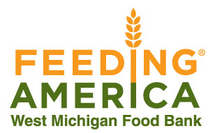
Food Drive and Fundraiser Form
Name of Company or Organization__________________________________________
Contact Person_________________________________________________________
Phone____________________Email Address_________________________________
Street Address__________________________________________________________
Food Drive/Fundraiser begins__________________and ends_____________________
Food Drive Goal____________________Fundraising Goal_______________________
(Every $1 provides 4 meals. 1 meal equals 1.28 pounds of food.)
Number of Collection Barrels requested_________________
Important: Due to the high costs of fuel and labor, you can save us a lot of money (which means we can provide more meals) by bringing the food to us. However, if this is not possible, we can pick up donations of more than 300 pounds within 20 miles of our Comstock Park warehouse. Call Katie Auwers at (616) 432-6961 to schedule a pickup. (Please note that during the months of November and December, our drivers’ schedules are heavily booked. Please allow at least a week’s notice for pickup. )
We request a digital version of your logo for promotional purposes. Yes/No
We request social media and event calendar promotion. (This does not guarantee promotion, though we will make a concerted effort to do so.) Yes/No
Please mail or email this completed form to

Katie Auwers
Feeding America West Michigan Food Bank
864 West River Center Drive
Comstock Park, MI 49321

katiea@feedingamericawestmichigan.org
616-432-6961

